**Web II Test 2**

1. Describe briefly what role a language like PHP plays in the development of websites and web applications? (4 marks)
2. Write the code to Create an HTML form that has has two inputs,salary and tax rate, a submit button and a PHP script which will receive the two values input and echo the result of computing the salary after the tax rate provided has been applied
3. Write brief notes on the terms below as they apply to web development: ( 4 marks@)
   * 1. Web server
     2. Web hosting
     3. Domain name

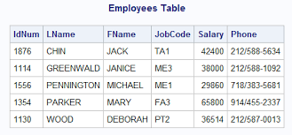

1. Consider the database table above named Employees in a database named *work*, with the database server at localhost with a username of *root* and password of *root*. Write scripts to do the following:
   1. Connect to the database using PHP( 3 marks)
   2. Send a query to return LName and FName and out put them as an un ordered list using PHP. (8 marks)
   3. Create an HTML form that would capture information to be inserted in the table above. (6 marks)
   4. Connect to the database and Insert your details as a new record in the table Employee from the form created in (iii) above.(8 marks)

<?php

$states = array("karnataka" => array

( "population" => "11,35,000", "captial" => "Bangalore"),

"Tamil Nadu" => array( "population" => "17,90,000",

"captial" => "Chennai") );

echo $states["karnataka"]["population"];

?>

1. Consider the code snippet above and answer the following questions:
   1. What will the output be of executing the code above?(2 marks)
   2. Use a Foreach loop to output all the above data in the array in an ordered list.(5 marks)